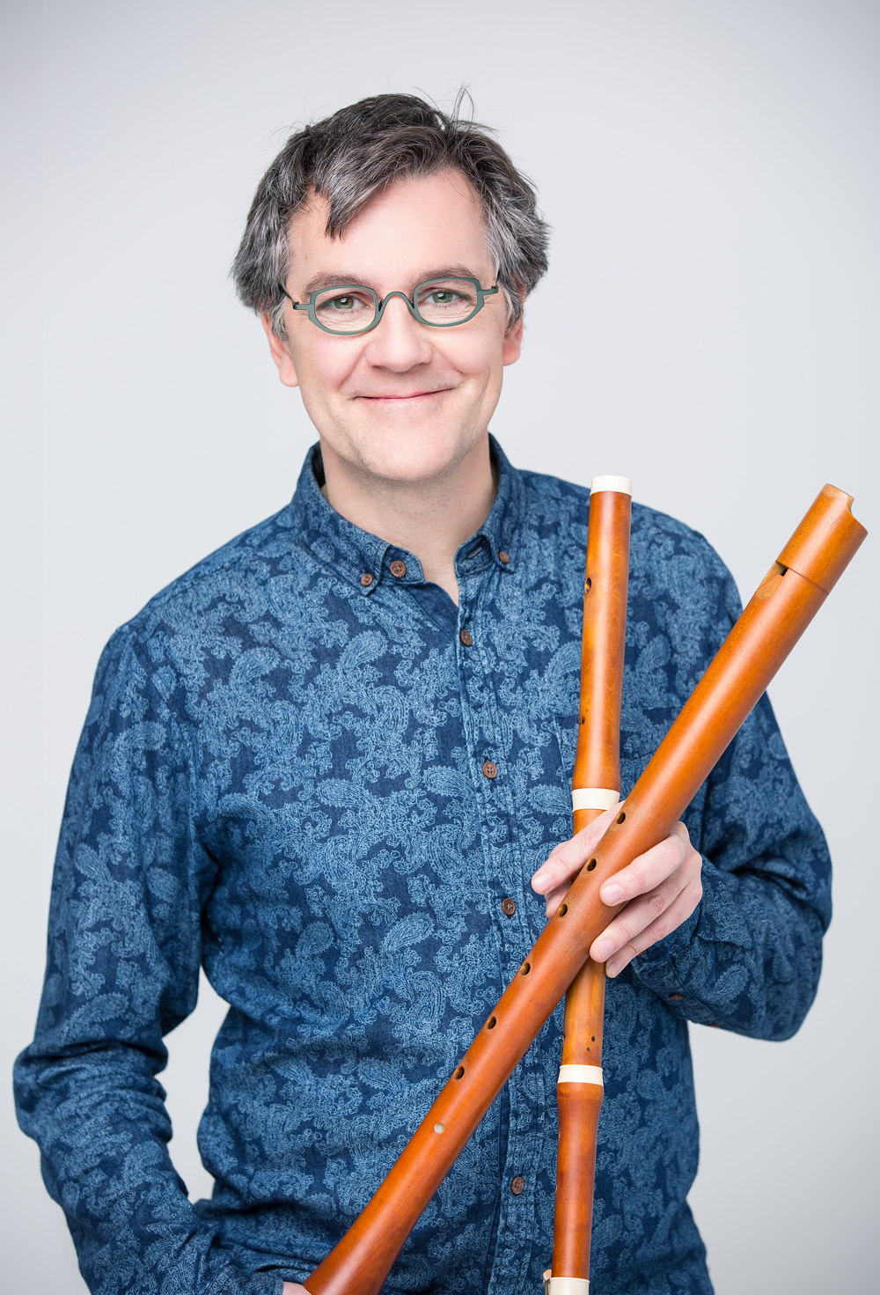 Francis Colpron
Instrumentalist (recorder and traverso) and actor

Recorder and traverso player Francis Colpron is recognized as one of the most talented musicians of his generation. During the past three decades, the public, critics, and cultural authorities have acclaimed his abilities to innovate as an artist and performer. In 1991, he founded the ensemble Les Boréades de Montréal, of which he is the artistic director, and which puts on a very successful annual concert series in Montreal, performs in North America and Europe, and records on the ATMA Classique label.

Les Boréades has performed with world-renowned artists such as Hervé Niquet, director of the Concert Spirituel de Paris; Skip Sempé, harpsichordist and director of Capriccio Stravagante; violinists Manfred Kraemer and Adrian Butterfield; harpsichordist Alexander Weimann; conductor Eric Milnes; cornettist William Dongois; recorder player Stefano Bagliano; oboe and conductor Alfredo Bernardini as well as with tenor Charles Daniels, and Canadian singers Matthew White, Karina Gauvin, and Laura Pudwell.

On stage, Francis Colpron, with Les Boréades, has explored the theatrical and musical worlds of the 17th and 18th centuries in shows such as Nicandro e Fileno (2017), Acis et Galatée (2015), La belle danse (2013), Tabarinades (2010), and Molière en Musique (2008). He has also acted in theatrical productions for young people such as La nuit de la Patate (2016) and Garde-Robe (2007). Noteworthy collaborators with Francis Colpron have included the directors Joël da Sylva and Jean-François Gagnon, and the actors Carl Béchard and Sophie Faucher.

Francis Colpron was associate flutist with Trinity Consort of Portland from 2000 to 2009. He has been a guest soloist with groups such as Apollo’s Fire of Cleveland, the Edmonton Symphony, the National Arts Centre Orchestra, Opera Atelier, Thirteen Strings, the Studio de musique ancienne de Montréal, Les Violons du Roy, the Nova Scotia Orchestra, and L’Harmonie des Saisons. As well as teaching at the Université de Montréal, he is frequently invited to share his experience as a teacher at well known summer music camps such as Amherst in the United States, CAMMAC in Quebec, and Boxwood in Nova Scotia.

His discography consists of more than 40 recordings.

Recordings

Soloist
Bravade, Jacob van Eyck & cie, ATMA, ACD 22160
Dieupart: Les Six Suites, ATMA, ACD 22 234/35
Frutti Musicali, ATMA, ACD 22303
Six Transcriptions, ATMA, ACD 22677

Les Boréades de Montréal

Baroque: Sonates virtuoses du XVIIe siècle, ATMA, ATM 29731
Noëls français du XVIIIe siècle aux instruments, ATMA, ACD2 2118
Private Musick, ATMA, ACD2 2132
Théâtre Musical, ATMA, ACD2 2152
Telemann: Suite & Concertos, ATMA, ACD2 2193
Beatles Baroque I, II, and III, ATMA, ACD2 2218, ACD2 2268, ACD2 2351
In Stilo Moderno, ATMA, ACD2 2217
Super Flumina Babylonis, ATMA, ACD2 2285
Acis & Galatea, ATMA, ACD2 2302
C.P.E Bach: Kammermusik, ATMA, ACD2 2322
Hyver, Karina Gauvin, soprano, ATMA, ACD2 2352
Purcell, Karina Gauvin, soprano, ATMA ACD2 2398
Alessandro Scarlatti: Concertos pour flûte, ATMA ACD2 2521
The Best of Beatles Baroque, ATMA ACD2 3008
Journey, ATMA ALCD2 1037
La Geniale: Sinfonias et Concertos, ATMA ACD2 2606
Du Baroque à la Bouche, ATMA ACDpromo
Tabarinades, musiques pour le théâtre de Tabarin, ATMA ACD2 2658
Nicandro e Fileno, ATMA ACD2 2770

Tafelmusik
J.H. Schmelzer: Sonatas, Balletti, Ciaconna, Vivarte, Sony Classical SK53963

Apollo’s Fire
Virtuoso Orchestra: Concertos by Bach, Vivaldi, & Heinichen, Live!, Apollo’s Fire/Jeannette Sorel, AF20-05

Les Voix Humaines
Captain Hume’s Poeticall Musicke, NAXOS 8.554 126/127
L’Étoile d’Orient, ATMA, ACD 22166
Primavera, ATMA, ACD 22258

Theatre of Early Music
Johann Sebastian Bach: Cantatas, ATMA, ACD2 2279
Johann Sebastian Bach: Actus tragicus, ATMA, ACD2 2288
Alessandro Scarlatti: Stabat Mater, ATMA ACD2 2237

Studio de Musique Ancienne de Montréal
Charpentier: Messe et Motets, ATMA, SACD2 2338

Montréal Baroque
Marin Marais: Sémélé, ATMA SACD 22527
Bach: La Nativité, ATMA SACD2 2403
I Mercanti di Venezia, ATMA ACD2 2598

Les Agréments de Montréal
Bach Requiem, XXI-21, XXI-CD21679

March 2019

