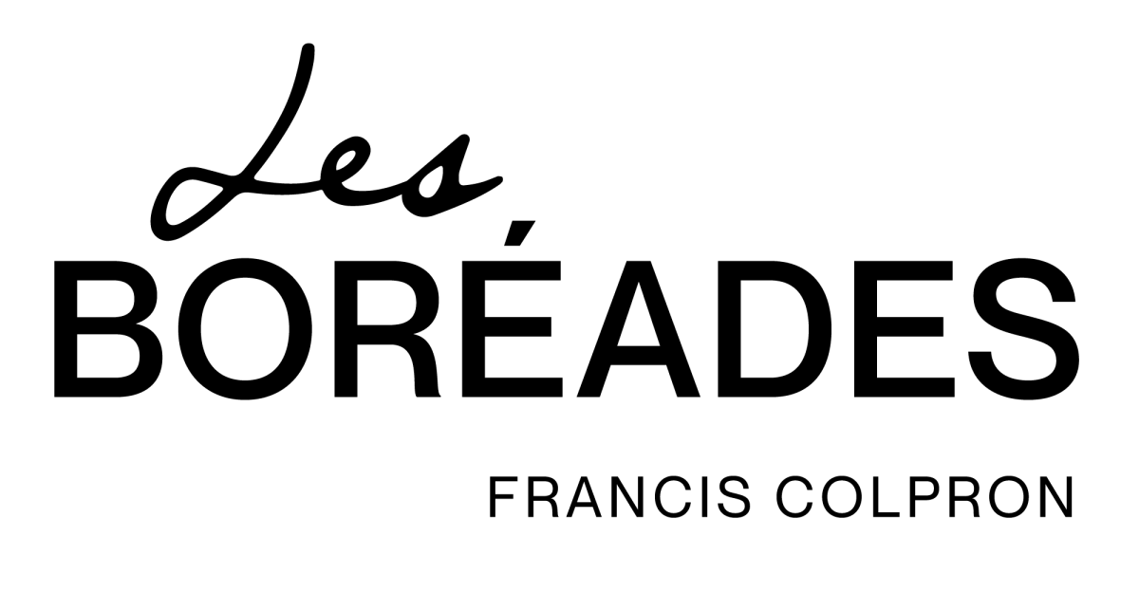

TECHNICAL RIDER

Maestro Mozart

Contact and tour responsible on site: Francis Colpron / Cell phone: 514.713.9120

Please note that the following requirements serve to provide the best possible conditions for the artists to perform most effectively. Please contact us immediately if any of these requirements pose a problem. Thank you.
The Company
For the Mozart program, the Boréades will comprise seven (7) musicians as well as a singer, and come without either a technician or an accompanist.
The musicians usually arrive 5 hours before the doors are opened to the public.
Between 2 pm and 5 pm, Les Boréades will hold a run-through without interruption.
Schedule
- 1 :30 pm: musicians arrive in the hall and set up
- 2 pm to 4 :30 pm: test of sound and of lighting cues
- 5 :30 pm: the concert organizer will arrange a meal for the seven musicians and a singer before the show.
Note: some members of the ensemble are vegetarians but none have food allergies.
The concert usually consists of two (2) 45-minute parts each with a 20-minute intermission.
Dressing Rooms
Separate and lockable dressing rooms for men and for women are required.
We require the following:
- Clean towels;
- A clean and working iron and ironing board;
- Tea, coffee, orange juice, flat water, and mineral water.

CD Sales
A table must be set up at the entrance to the concert hall for the sale of CDs during public concerts. An employee of the concert hall with enough petty cash to make change will be assigned to look after the sale of CDs and related products.
Technical Requirements
Les Boréades needs the equipment listed below to be supplied by the concert organizer.
Sound
Equipment required:
The musicians of Les Boréades play period instruments. Ambient amplification may be necessary. The decision to use such amplification will be made during the run through. To discuss this requirement before the show, please contact Félix Lefebvre, sound and technical director at 514.882.5661. (felix.lefebvre@videotron.ca)
Equipment needed for capturing ambient sound:
Wireless stick microphone (Shure or Seinheiser)
a) Digital sound mixer in the concert hall: 12 inputs/4 outputs minimum (Digital mixing board – minimum 12 Inputs/4 outputs). This mixer must be able to send produce reverb effects into the mixer's inputs. (Reverb hall/Reverb plate)
b) High quality sound system (High quality P.A. system): e.g. Meyers/D&B
c) Four high-quality condenser microphones (4 high-quality condenser Microphones) up front to capture the ensemble.
Option 1: 4 Large Diaphragm Condenser Microphones (Ex: AKG C-314, AT4050, NM TLM102)
Option 2: 6 Condenser microphones with narrow diaphragm (Ex: NM KM184, Rhode NT5, AKG C451)
Note: A mixture of the two can also be done. All must be approved by Les Boréades' technical director.
d) All appropriate audio cabling to the control panel.
N.B. For any questions, contact us.
Stage
Accessories required:
a) Seven (7) identical stands (adjustable and preferably black)
b) Seven (7) identical chairs without armrests, preferably black
c) 3 stages riser (4 by 8 foot) and six inch legs hight for the singer

Lighting
Normal stage lighting (general cover in open white)

